Our ECE is:
Insert ECE logo
Recycling Oral Care Waste Products!
We request all Kaiako, whānau and our wider ECE community to drop off their oral care waste products in this box, this includes:
ANY BRAND toothpaste tubes, stand up bottles, toothbrushes and packaging, interdental brushes, dental floss containers, and mouthwash bottles
x NO electric toothbrushes parts x
Please ensure all excess product has been removed and completely dry.
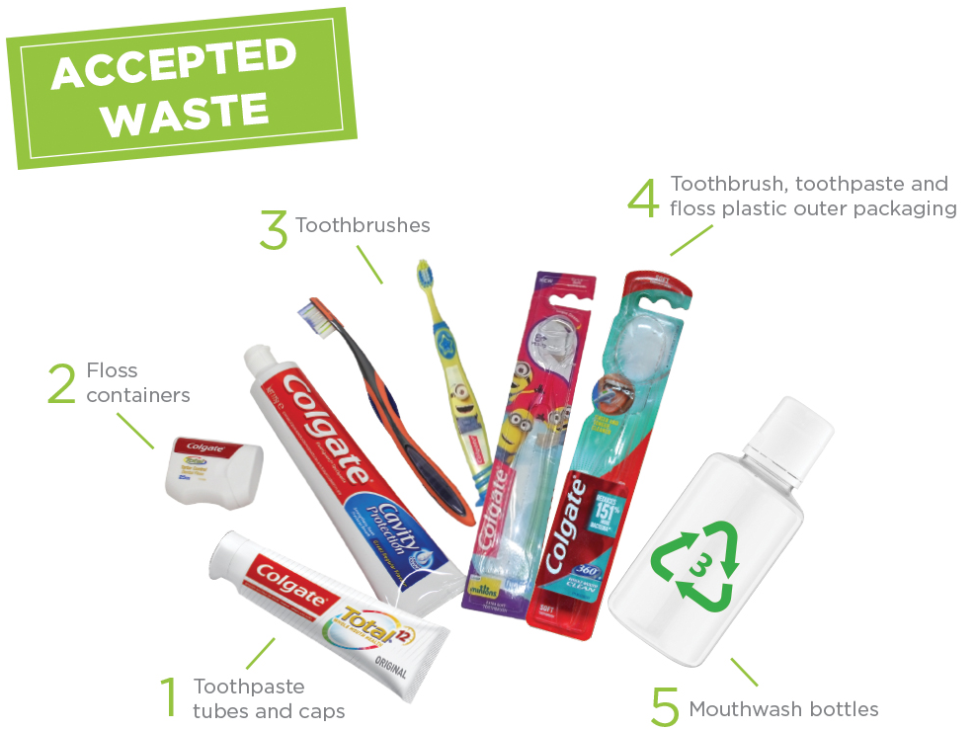

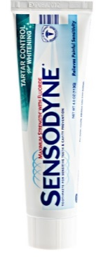

Note: Please recycle your cardboard-only packaging in your kerbside recycling (yellow bin).
Once the oral care waste products reaches 5kg, it will be shipped off to TerraCycle so that it can be melted and re-moulded to make new recycled products. For more information visit: www.terracycle.com/en-NZ/brigades/oral-care-brigade
Thank you for supporting us to prevent all this waste from going into landfills!

